**How Python and Rest API can save your hours on Tableau server Maintenance and you can?**

**Problem statement: Our database password is changing after a certain frequency as per legal guidelines, due to the same our all extract stopped refreshing and someone has to login into server and change the password manually in each extract, which is nightmare for server administrator.**

**Let’s understand how we can solve above problem statement!**

**Here I will update password of one of my existing extract available on server, having said that you can update password of all extract in one go by using loop in python.**

## **What is Rest API?**

With the Tableau Server REST API you can manage and change Tableau Server resources programmatically, using HTTP. The API gives you simple access to the functionality behind the data sources, projects, workbooks, site users, and sites on a Tableau server. You can use this access to create your own custom applications or to script interactions with Tableau Server resources.

**Let’s Set the Stage:**

We need following stuff on laptop /desktop / server

1. Python (Jupyter Notebook)
2. Important Python libraries
3. tableau-api-lib
4. pandas (this will get installed by default during the installation of Jupyter)

To get above API please use below commands to install for python

Pip install --upgrade tableau-api-lib

Pip install --upgrade pandas

Let’s start writing our script

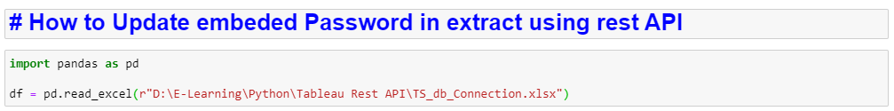

Note: I have kept all confidential information in central configuration file, which look like something below



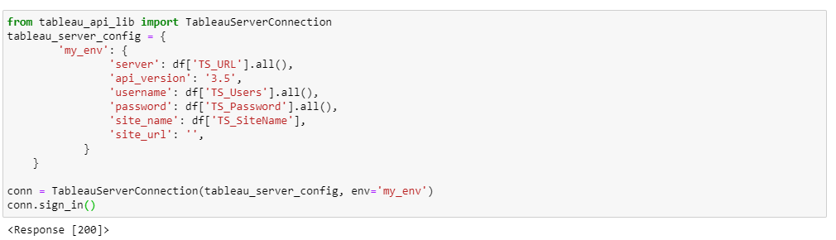

If you have passed everything correctly then you must be getting like **200,** if it is other than 200 then visit your credentials set in your configuration file.

Note: To update the password of extract you need following things before you proceed

1. DataSource ID
2. Connection ID

You can get above information using two methods, first connect your tableau repository database (workgroup). For this your repository access needs to be enabled. If you don’t know how to enable the same please visit [**Enable Repository**](https://help.tableau.com/current/server/en-us/perf_collect_server_repo.htm#:~:text=Enable%20access%20to%20the%20Tableau%20Server%20repository,-You%20can%20use&text=Before%20you%20can%20connect%20to,command%20to%20enable%20repository%20access.)

Or follow below python steps to get the same using rest API.

First will get data Source ID for that will execute below



Now our next step to get connection detail for your extract data source ID, to get the same execute below code – You have to pass the data source id to get the connection id

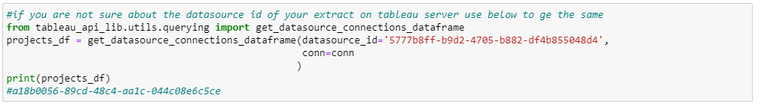

Now you have both things with you, Datasource ID and Connection ID. Now let’s move to next step to update the Password

